EasyCRUD – THREE TIER ARCHITECTURE ON AWS

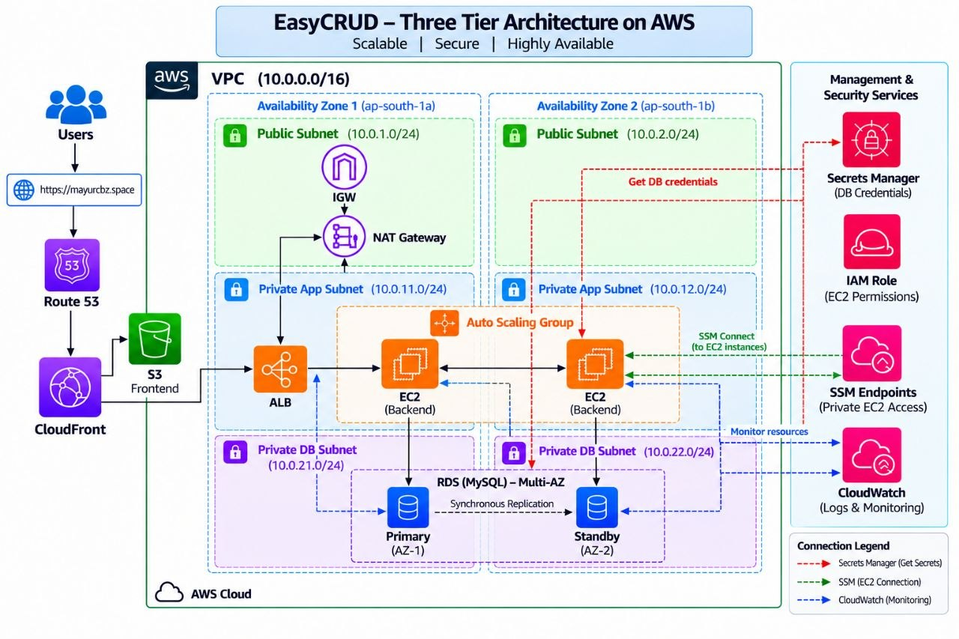
We separate the infrastructure into three logical layers:
- Public subnet → internet-facing resources
- Private application subnet → backend servers
- Private database subnet → database

PHASE-1 VPC

1.create a vpc
- name -- easycrud-vpc
- cidr ---- 10.0.0.0/16
2.create a subnet
- public-subnets
- easycrud-public-1 --- 10.0.1.0/24
- easycrud-public-2 --- 10.0.2.0/24
- private-subnets
- easycrud-private-app-1 --- 10.0.11.0/24
- easycrud-private-app-2 --- 10.0.12.0/24
- private-database-subnets
- easycrud-private-db-1 --- 10.0.21.0/24
- easycrud-private-db-2 --- 10.0.22.0/24
3.Enable public IPv4 - public-subnet-1
- click on public-subnet-1
- go to actions
- click on edit subnet settings
- enable -- auto-assign public IPv4 address
- save
4.Enable public IPv4 - public-subnet-2
- click on public-subnet-2
- go to actions
- click on edit subnet settings
- enable -- auto-assign public IPv4 address
- save
5.create an internet gateway (easycrud-igw) and attach to vpc
6.create a public-route-table
- name --- easycrud-public-rt
- route
- destination -- 0.0.0.0/0
- target --------- easycrud-igw
- associate public subnets
- easycrud-public-1
- easycrud-public-2
5.create a nat gateway
- name ----- easycrud-nat
- subnet --- easycrud-public-1
- connectivity -- public
- allocate elastic ip address
- create a nat gateway
6.create a private route table
- name --- easycrud-private-app-rt
- route
- destination -- 0.0.0.0/0
- target --------- easycrud-nat
- associate private subnets
- easycrud-private-app-1
- easycrud-private-app-2
7.create a database route table
- name ----- easycrud-private-db-rt
- associate
- easycrud-private-db-1
- easycrud-private-db-2

PHASE – 2
8.create a role
- name ---- easycrud-role
- entity -- EC2
- permissions attach
- AmazonSSMManagedInstanceCore
- CloudWatchAgentServerPolicy
- create a role
9.Add secrets manager permission
- create a inlined policy in easycrud-role
- add the json policy

{
"Version": "2012-10-17",
"Statement": [
{
"Sid": "ReadEasyCRUDRDSSecret",
"Effect": "Allow",
"Action": [
"secretsmanager:GetSecretValue"
],
"Resource": "YOUR_RDS_SECRET_ARN"
}
]
}

{Replace: YOUR_RDS_SECRET_ARN}
- policy name - easycrud-read-rds-secret
- create policy
9.create a SSM vpc Endpoints
Because the backend instances are private, we configured VPC endpoints so that SSM can work without a public IP.
- Enable vpc
10.Enable VPC DNS Support
- click on easycrud vpc
- go to actions -- edit vpc settings
- DNS resolution -- enable
- DNS hostnames -- enable
- save changes
11.Create VPC Endpoint Security Group
- go to security group
- create a security group
- name ---- easycrud-vpce-sg
- Description → EasyCRUD VPC Endpoint SG
- vpc ----- easycrud-vpc
- Inbound Rules
- type ---- https
- port ---- 443
- source -- custom
- CIDR ---- 10.0.0.0/16
- Outbound Rule
- type ---- all traffic
- Destination --- 0.0.0.0/0
- create security group
12.Create SSM Endpoint
- Go to endpoint
- create a endpoint
- Name → easycrud-ssm-endpoint
- Service category → AWS services
- Service → com.amazonaws.ap-south-1.ssm
- VPC → easycrud-vpc
- Endpoint type → Interface
- subnets
- easycrud-private-app-1
- easycrud-private-app-2
- security group ---- easycrud-vpce-sg
- policy --- full access
- create a endpoint
13.Create EC2 Messages Endpoint
- Go to endpoint
- create a endpoint
- Name → easycrud-ec2messages-endpoint
- Service category → AWS services
- Service → com.amazonaws.ap-south-1.ec2messages
- VPC → easycrud-vpc
- Endpoint type → Interface
- subnets
- easycrud-private-app-1
- easycrud-private-app-2
- security group ---- easycrud-vpce-sg
- policy --- full access
- create a endpoint
14.Create SSM Messages Endpoint
- Go to endpoint
- create a endpoint
- Name → easycrud-ssmmessages-endpoint
- Service category → AWS services
- Service → com.amazonaws.ap-south-1.ssmmessages
- VPC → easycrud-vpc
- Endpoint type → Interface
- subnets
- easycrud-private-app-1
- easycrud-private-app-2
- security group ---- easycrud-vpce-sg
- policy --- full access
- create a endpoint
15.Create S3 Gateway endpoint
- Go to endpoint
- create a endpoint
- Name → easycrud-s3-endpoint
- Service category → AWS services
- Service → com.amazonaws.ap-south-1.s3
- VPC → easycrud-vpc
- Endpoint type → Gateway
- Route tables ------ easycrud-private-app-rt
- policy --- full access
- create a endpoint

PHASE – 3 RDS & SECRETS MANAGER
1.Create a DB subnet group
- name ---- easycrud-db-subnet-group
- Description → EasyCRUD DB subnet group
- VPC → easycrud-vpc
- Availability Zones →
- ap-south-1a
- ap-south-1b
- Subnets →
- easycrud-private-db-1
- easycrud-private-db-2
- create a subnet group
2.create a RDS Database
- machine name ---- MySQL
- DB instance identifier → easycrud-rds
- username ----- admin
- credentials ---- Managed in AWS Secrets Manager
- Compute resource → Don't connect to an EC2 compute resource
- VPC → easycrud-vpc
- DB subnet group → easycrud-db-subnet-group
- Public access → No
- VPC security group → easycrud-rds-sg
- Initial database name → student_db
- Backup retention period → 7 days
- create a database
3.Get the Secrets Manager Secret
- go to secrets manager
- click on the secrets
- You get
- username
- password
- engine
- host
- port
- dbname
- Important
- We do not copy the password into:
  - EC2 user data
  - application.properties
  - GitHub
  - source code
4.Go to Security Group
- click on easycrud-rds-sg
- edit inbound
- type --- MySQL/Aurora
- source - easycrud-backend-sg
At this point, if easycrud-backend-sg hasn't been created yet, don't create a 0.0.0.0/0 rule.
We'll create easycrud-backend-sg in the backend phase and then add it as the source.

PHASE - 4 BACKEND CONFIGURATION – SSM
1.create a backend-security-group
- sg name → easycrud-backend-sg
- Description → EasyCRUD Backend Security Group
- VPC → easycrud-vpc
- inbound rules
- type -- custom TCP
- port -- 8080
- source - custom
- source -- 10.0.0.0/16
- create a sg
Later, after creating the ALB security group, we will change this rule to allow 8080 only from easycrud-alb-sg.
2.Update RDS security group
- click on easycrud-rds-sg & edit these rule
- type ---- MySQL/Aurora
- port ---- 3306
- source -- custom
- soure --- easycrud-backend-sg
- create a sg
3.Create a Backend EC2
- name ---- easycrud-backend-1
- os -------- amazon-Linux 2023
- type ----- t3.micro
- key pair - Proceed without a key pair
- vpc ------ easycrud-vpc
- subnet --- easycrud-private-app-1
- public ip - disable
- sg name --- easycrud-backend-sg
- Iam instance profile -- easycrud-role
- launch instance
4.Connect using SSM
- Go to SSM
- click on easycrud-backend-1
- connect to terminal
5.Configuration on easycrud-backend-1
- dnf update -y
- sudo dnf install java-17-amazon-corretto -y
- sudo dnf install git -y
- sudo dnf install maven -y
- java --version
- git --version
- aws --version
- mvn --version
- cd /opt
- git clone https://github.com/mayurpandit25/EasyCRUD-Updated-df.git
- sudo chown -R ssm-user:ssm-user /opt/EasyCRUD-Updated-df
- sudo find /opt/EasyCRUD-Updated-df -type d -exec chmod 755 {} \;
- sudo find /opt/EasyCRUD-Updated-df -type f -exec chmod 644 {} \;
- cd /opt/EasyCRUD-Updated-df/
- vim backend/src/main/resources/application.properties
server.port=8080
spring.datasource.url=jdbc:mariadb://${DB_HOST}:${DB_PORT:3306}/${DB_NAME}?sslMode=trust
spring.datasource.username=${DB_USER}
spring.datasource.password=${DB_PASSWORD}
spring.jpa.hibernate.ddl-auto=update
spring.jpa.show-sql=false
management.endpoints.web.exposure.include=health,info
management.endpoint.health.show-details=never

- cd /opt/EasyCRUD-Updated-df/backend
- mvn clean package -DskipTests
- ls target/
6.Tests Secrets Manager Access
- sudo aws secretsmanager get-secret-value --secret-id "YOUR_RDS_SECRET_ARN" --region ap-south-1
7.Set Database Environment Variables Commands
- export DB_HOST="YOUR_RDS_ENDPOINT"
- export DB_PORT="3306"
- export DB_NAME="student_db"
- export DB_USER="admin"
Replace: ( Your_RDS_Endpoint)
8.Get the password from Secrets Manager:
export DB_PASSWORD=$(aws secretsmanager get-secret-value \
--secret-id "YOUR_RDS_SECRET_ARN" \
--region ap-south-1 \
--query SecretString \
--output text | python3 -c 'import sys,json; print(json.load(sys.stdin)["password"])')
9.Start Backend
- cd /opt/EasyCRUD-Updated-df/backend
- nohup java -jar target/student-registration-backend-0.0.1-SNAPSHOT.jar > backend.log 2>&1 &
- lsof -i :8080
- tail -f backend.log
10.Test Backend Locally
- curl http://localhost:8080/api/users

PHASE – 5 CREATION OF AMI
1.create a AMI From backend EC2
- select instance --- easycrud-backend-1
- click on Actions
- click on Image and Templates
- Image name → easycrud-backend-ami
- Image description → EasyCRUD Backend AMI
- create image

PHASE – 6 AUTOSCALING
1.Create launch template
- Launch template name → easycrud-backend-lt
- Template version description → EasyCRUD backend
- AMI ---- My AMIs
- AMI ---- easycrud-backend-ami
- type --- t3.micro
- Key pair → Don't include in launch template
- subnet → Don't include in launch template
- Auto-assign public IP → Disable
- sg name --- easycrud-backend-sg
- IAM instance profile → easycrud-role
- user-data
#!/bin/bash

SECRET_ARN="YOUR_RDS_SECRET_ARN"

DB_HOST="YOUR_RDS_ENDPOINT"
DB_PORT="3306"
DB_NAME="student_db"
DB_USER="admin"

DB_PASSWORD=$(aws secretsmanager get-secret-value \
--secret-id "$SECRET_ARN" \
--region ap-south-1 \
--query SecretString \
--output text | python3 -c 'import sys,json; print(json.load(sys.stdin)["password"])')

cat > /etc/easycrud-backend.env <<EOF
DB_HOST=$DB_HOST
DB_PORT=$DB_PORT
DB_NAME=$DB_NAME
DB_USER=$DB_USER
DB_PASSWORD=$DB_PASSWORD
EOF

chmod 600 /etc/easycrud-backend.env

cat > /etc/systemd/system/easycrud-backend.service <<'SERVICE'
[Unit]
Description=EasyCRUD Spring Boot Backend
After=network-online.target
Wants=network-online.target

[Service]
User=ec2-user
WorkingDirectory=/opt/EasyCRUD-Updated-df/backend
EnvironmentFile=/etc/easycrud-backend.env
ExecStart=/usr/bin/java -jar /opt/EasyCRUD-Updated-df/backend/target/student-registration-backend-0.0.1-SNAPSHOT.jar
Restart=always
RestartSec=10

[Install]
WantedBy=multi-user.target
SERVICE

systemctl daemon-reload
systemctl enable easycrud-backend
systemctl start easycrud-backend

12.Replace
- YOUR_RDS_SECRET_ARN
- YOUR_RDS_ENDPOINT
13.Create a launch template
3.Create A auto scaling group
- asg name --- easycrud-backend-asg
- launch template --- easycrud-backend-lt
- version ---- latest
- vpc -------- easycrud-vpc
- subnets
- easycrud-private-app-1
- easycrud-private-app-2
- desired capacity -- 2
- minimum capacity -- 2
- maximum capacity -- 4
- create a auto scaling group

PHASE – 7 LOAD BALANCING
1.create a ALB security group
- Security group name → easycrud-alb-sg
- Description → EasyCRUD ALB Security Group
- VPC → easycrud-vpc
- Inbound Rules
- type --- http
- port --- 80
- source - Anywhere-IPv4
- CIDR --- 0.0.0.0/0
2.Update Backend Security Group
- edit the easycrud-backend-sg
- type ---- custom TCP
- port ---- 8080
- source -- custom
- source -- easycrud-alb-sg
- save rules
3.Create a Target Group
- type ------- instances
- tg name ---- easycrud-backend-tg
- protocol --- HTTP
- Port ------- 8080
- vpc -------- easycrud-vpc
- health check protocol --- HTTP
- Health Check path ------- /api/users
- port ---- traffic port
- create a target group
4.Add target group in the autoscaling group
- go to autoscaling group
- add the target group in the autoscaling group
5.Create a Application load balancer
- lb name ---- easycrud-alb
- scheme ----- internet-facing
- vpc -------- easycrud-vpc
- subnets
- easycrud-public-1
- easycrud-public-2
- sg --------- easycrud-alb-sg
- protocol --- HTTP
- port ------- 80
- forward to - easycrud-backend-tg
- create a load balancer
6.Check the health of instance in target group
7.Test ALB
- http://YOUR-ALB-DNS

PHASE - 8 CLOUDWATCH WITH SNS & AUTOSCALING POLICY
1.go to SNS
1.create a topic first (easycrud-app)
2.create a subscription
- endpoint -- email
- email end -- mayur@gmail.com
2.Go to CloudWatch
- create a alarm
3.create a autoscaling policy
- go to easycrud-backend-asg
- click on asg
- click on instance scaling
- create a dynamic scaling policy
- name --- increase scaling policy
- alarm -- add the cloudwatch alarm
- add ---- 2
- create a autoscaling policy

PHASE - 9 BUILD FRONTEND
1.Create a s3 bucket
mayurcbz.space
Build Frontend Locally
- git clone https://github.com/mayurpandit25/EasyCRUD-Updated-df.git
- cd EasyCRUD-Updated-df
- cd frontend
- vim .env
VITE_API_URL=/api
- npm install
- npm run build
- ls dist/
- aws s3 cp dist/ s3://mayurcbz.space/
- aws s3 ls s3://mayurcbz.space/
- Enable static website hosting and test the frontend

PHASE – 10 {ACM - ROUTE-53 – CLOUDFRONT}
1.create a route 53 hosted zone
- mayurcbz.space
2.Create a ACM certificates in North Virginia
- domain name → mayurcbz.space
- request certificates
- After that create a record in route 53
3.Create CloudFront Distribution
- Distribution name → mayurcbz.space
- Description → mayurcbz.space
- Route 53 managed domain → mayurcbz.space
- origin type → amazon s3
- s3 origin → select bucket (do not select the static website URL)
- select the acm certificates arn
- create a CloudFront distribution
4.Edit the CloudFront
  - Default root object ---> index.html
5.Edit the CloudFront
- Alternate domain names ---> mayurcbz.space
6.Edit the CloudFront
- go to origins
- create a origin
- Origin domain ----> easycrud-alb (select a load balancer)
- origin name -------> easycrud-alb-origin
- create a origin
7.Edit the CloudFront
- click on behaviour
- create a behaviour
- Path pattern → /api/*
- Origin → easycrud-alb-origin
- Viewer protocol policy → Redirect HTTP to HTTPS
- Cache policy → CachingDisabled
- Origin request policy → AllViewerExceptHostHeader
- create a behaviour
8.Create a record in route 53
- create a record
- record type -- A
- alias
- select CloudFront Distribution
- region --- ap-south-1
- endpoint – (CloudFront-dns-name)
- create a record
9. Test the Domain name
- https://mayurcbz.space ---------> Frontend
- https://mayurcbz.space/api/ ---> Backend

